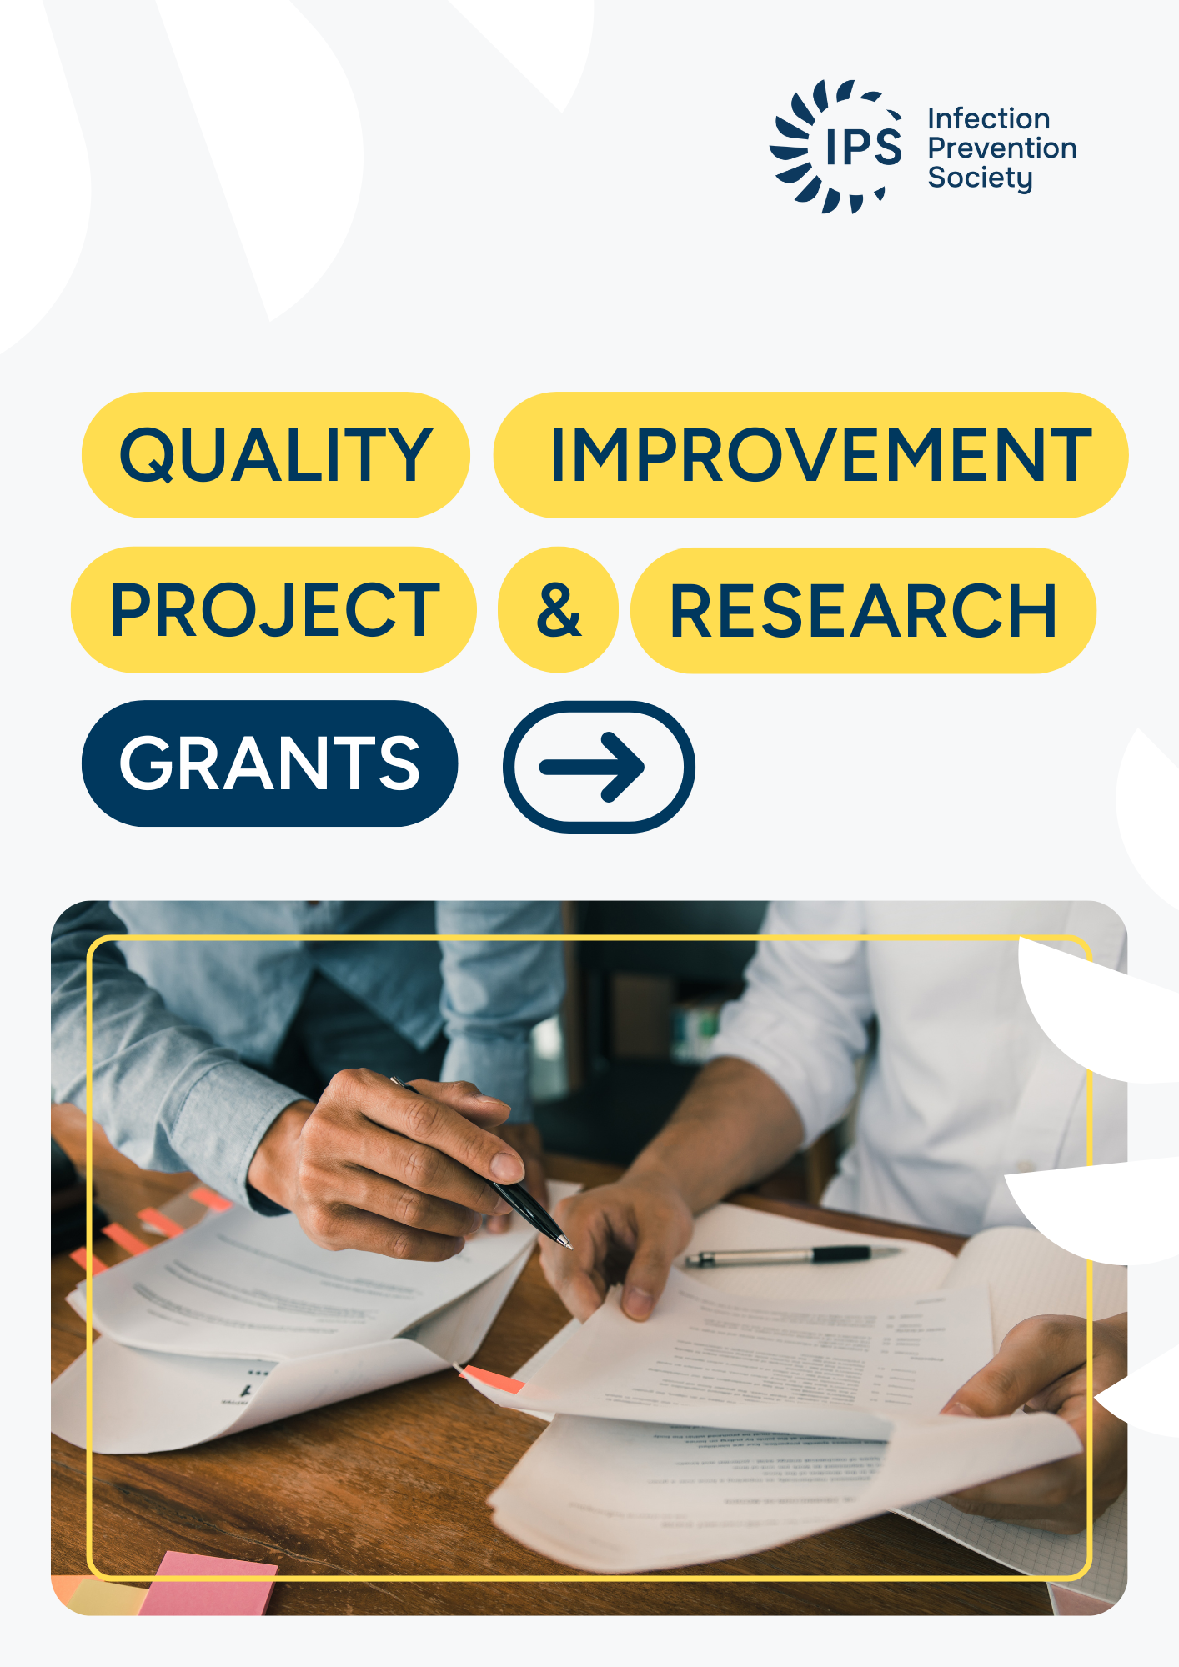

Infection Prevention Society Quality Improvement Project & Research Grants

The Grants play a pivotal role in the realisation of three key elements of the IPS Research Strategy to:

- generate high quality research and quality improvement projects (QIPs) for practice.
- engage in collaborative research with academic and clinical partners.
- develop QIP and research capability and capacity among its members.

The aim of Infection Prevention Society (IPS) QIP & Research Grants is to support high quality QIPs and practice-based research within the field of infection prevention and control (IPC). A pool of funds is available each year to the IPS Research and Development (R&D) committee to support small research grants.

Applications are encouraged from IPS members at all career stages (this includes members who are new to IPC and members who are established in IPC). Novice investigators (that is, applicants with little or no QIP/research experience) are welcome to apply, providing that an experienced investigator with proven QIP or research experience is named in the application as a supervisor or co-applicant.

Please consider applying if you are thinking of doing a piece of work that is designed to improve any aspect of IPC practice and find a better way of working, whatever the setting. Examples include (but are not limited to) digital working improvements, patient safety initiatives, sustainability related improvements, behavioural science related investigations, AMR related research etc.

There is an expectation that the applicants for any of the grants awarded will produce reports on progress throughout the project and inform the R&D committee of any mitigating circumstances or proposed changes to the study that may impact on the grant awarded.

CLOSING DATE
Round 2: Applications must be submitted by midday Friday 30th January 2026. Applications received after respective deadlines will not be considered.

Applicants should send a signed electronic copy of the application to Lynne Duncan, IPS Governance & Engagement Manager: lynne.duncan@ips.uk.net

GRANT CRITERIA
This is a competitive process and all applications will be independently peer-reviewed and final decisions made by the IPS R&D Committee. The grants will be awarded based on the following criteria:

- Eligibility
  - The lead applicant must be a current member of IPS and has been for at least 12 months prior to the application (applicants are required to maintain their membership for the duration of the grant).
  - The lead applicant holds an appropriate academic qualification and/or relevant QIP or research experience as judged by the grants panel.

- Originality and scientific merit of the proposal

  - The proposal is original or if similar QIP or research has been done before the applicant(s) provides evidence that replication will add value to current scientific knowledge.
  - The overall design is appropriate for answering the question suggested by the applicant.
  - The plan for analysing the data is clear.
  - Ethical issues have been considered and addressed in the research study, where applicable.
  - The study outputs will have impact on the prevention of infection and/or patient care.

- Time and financial resource are sufficient and reasonable.

  - The resources requested are appropriate and justified for the scale, methods and purpose indicated by the applicant(s).
  - The scope of the work is achievable within the time frame.
  - Any other sources of funding/ support to the proposed study is declared (this includes employer support).

- Project Management/ Supervision

  - There is appropriate QIP or research supervision/support available for novice investigators.
  - There is a project management plan and appropriate oversight to ensure that the project is undertaken according to any external approvals (e.g., NHS NRES/HSE) and within the time frame and budget set out.
  - Evaluation of risks and possible contingencies.

SECTION 1: PROJECT TITLE AND APPLICANT DETAILS

PROJECT TITLE |  | Click or tap here to enter text.
Start date: | Click or tap to enter a date. | End date: | Click or tap to enter a date.

NAME AND CONTACT DETAILS OF LEAD APPLICANT |  | Click or tap here to enter text.
IPS membership number |  | Click or tap here to enter text.
Name |  | Click or tap here to enter text.
Job title |  | Click or tap here to enter text.
Work address |  | Click or tap here to enter text.
Email | Click or tap here to enter text. | Phone | Click or tap here to enter text.

NAME AND CONTACT DETAILS OF QIP/RESEARCH SUPERVISOR (NOVICE INVESTIGATORS ONLY)

Name |  | Click or tap here to enter text.
Job title |  | Click or tap here to enter text.
Work address |  | Click or tap here to enter text.
Email | Click or tap here to enter text. |  | Phone | Click or tap here to enter text.

ADDITIONAL APPLICANTS

Applicant 2
IPS membership number |  | Click or tap here to enter text.
Name |  | Click or tap here to enter text.
Job title |  | Click or tap here to enter text.
Work address |  | Click or tap here to enter text.
Email | Click or tap here to enter text. | Phone | Click or tap here to enter text.

Applicant 3
IPS membership number |  | Click or tap here to enter text.
Name |  | Click or tap here to enter text.
Job title |  | Click or tap here to enter text.
Work address |  | Click or tap here to enter text.
Email | Click or tap here to enter text. | Phone | Click or tap here to enter text.

Applicant 4
IPS membership number |  | Click or tap here to enter text.
Name |  | Click or tap here to enter text.
Job title |  | Click or tap here to enter text.
Work address |  | Click or tap here to enter text.
Email | Click or tap here to enter text. | Phone | Click or tap here to enter text.

Applicant 5
IPS membership number |  | Click or tap here to enter text.
Name |  | Click or tap here to enter text.
Job title |  | Click or tap here to enter text.
Work address |  | Click or tap here to enter text.
Email | Click or tap here to enter text. | Phone | Click or tap here to enter text.

SECTION 2: PROPOSAL DETAILS

ABSTRACT (This should be a lay summary in no more than 500 words and will appear on the IPS website)

OUTLINE PROPOSAL: Use the following headings and continue on additional pages.

- QIP/RESEARCH QUESTION(S):

- AIM(S) OF THE PROJECT:

- BACKGROUND (summarise the scientific/ theoretical/ conceptual background to the project, including the importance of the problem, its impact on patient care, infection prevention and control and healthcare delivery, a summary of the current evidence and how the proposed project will add to the existing evidence base. 500 words)

- QIP METHODOLOGY/STUDY DESIGN (provide a justification for the study design. This should highlight the rigour of the design in the context of the proposed question 500 words)

- DATA COLLECTION AND ANALYSIS METHODS (provide a brief description of the methods used to collect data and the processes to be used for analysis. If appropriate include details of the sample size or number of informants. (500 words)

- ETHICAL ISSUES AND APPROVALS (if applicable) (provide a brief description of any ethical issues that need to be managed in this study and whether ethical approval will be sought and where from e.g., NHS RES/HSE. 250 words).

- PROPOSED IMPACT ON CLINICAL PRACTICE AND/OR POLICY (250 words):

- DETAILS OF PROJECT MANAGEMENT (provide a project plan for the study, this should include timelines for each stage of the research and details of project management meetings.)

- EVALUATION OF RISKS AND POSSIBLE CONTINGENCIES Submission of a grant application to the IPS R&D Committee is taken as confirmation that the applicant is aware of and accepts any risks associated with the project. Identify risks (e.g. space, contracts, and costs) and contingency plan mitigating actions.

SECTION 3: FINANCIAL DETAILS

TOTAL AMOUNT of FUNDING SOUGHT £

SUMMARY OF FUNDING REQUESTED (please indicate how the grant will be used. This may include items such as: data recording devices; analysis software; aspects of research training; secretarial support for transcription or data entry; reimbursement of expenses for research participants; laboratory tests that are additional to standard of care; incidental travel expenses for data collection or collaborative group meetings; stationery and postage. Please note that travel costs should not form the majority of the funding request. Grants should not be used to fund attendance at conference.

Item | Brief justification of cost | Cost £
Click or tap here to enter text. | Click or tap here to enter text. | Click or tap here to enter text.
Total |  | £Click or tap here to enter text.

DETAILS OF OTHER FUNDING OR SUPPORT INCLUDING COSTS (this will include study leave granted by an employer or research funding from local or other national funders)

SECTION 4 – CURRICULM VITAE OF EACH APPLICANT (Please duplicate the following format for each applicant and research supervisor where appropriate)

Surname |  | Forename(s) |  | Designation:
Click or tap here to enter text. |  | Click or tap here to enter text. |  | Click or tap here to enter text.

Professional qualifications (with date) | Click or tap here to enter text.
Highest Degree (subject, class, university, and date) | Click or tap here to enter text.
Non-degree related Research Training where applicable, e.g. ENB programme, Good Clinical Practice (GCP) | Click or tap here to enter text.

Posts held in the past 5 years most recent first.
Click or tap here to enter text.

Involvement in research projects; QIP projects, publications including papers in press.

Click or tap here to enter text.

Membership of professional or national/ regional working parties.R&D

Click or tap here to enter text.

SECTION 5: TERMS AND CONDITIONS OF THE GRANT

The applicant(s) agree to the following conditions on acceptance of the grant:
1. Project Delivery and Use of Funds
1.1. The grant is awarded on the condition that the applicant(s) complete the project as outlined in the approved application and in accordance with these Terms and Conditions.
1.2. No alterations to the project scope, objectives, budget, or timeline may be made without the prior written approval of the IPS Research and Development (R&D) Committee. Any such requests must be submitted in writing with a clear rationale for the proposed changes.
1.3. All projects must commence within the financial year (1 April – 31 March) of approval and in line with the agreed project timeline as detailed in the Funding Agreement. Failure to initiate the project within this period will result in automatic withdrawal of funding.
1.4. If the applicant(s) decide not to proceed with the project, they must notify IPS in writing immediately and arrange to return any funds already transferred.
1.5. If the applicant(s) are unable to complete the project as approved, they must notify IPS in writing immediately. In these circumstances applicant(s) may be required to reimburse funds already transferred and spent.
1.6. Applicants must maintain accurate financial records and provide evidence of expenditure as requested.
1.7. Any funds remaining unspent at the end of the approved project timeline (please refer to the Funding Agreement) must be returned to the Infection Prevention Society without delay. Extensions to utilise unspent funds will only be considered in exceptional circumstances and must be approved in writing by the IPS R&D Committee in liaison with the IPS Financial Controller prior to the project end date.

2. Progress and Financial Reporting
2.1. Applicants must submit interim project reports to the IPS R&D Committee at agreed intervals throughout the duration of the project. Each report must include a summary of progress and a detailed record of expenditure to date.
2.2. Continued release of funding is conditional upon the satisfactory submission and review of interim reports.

3. Final Reporting
3.1. A comprehensive final report detailing the research outcomes and full expenditure must be submitted to the IPS R&D Committee within two (2) months of project completion.
3.2. A testimony and/or a blog/vlog summarising the project and its impact must be provided for publication on the IPS website within three (3) months of project completion.

4. Publication and Dissemination
4.1. The financial support of the Infection Prevention Society must be acknowledged in all publications, presentations, and other outputs arising from the research project.
4.2. A Quality Improvement Project (QIP) or research paper based on the findings must be developed and submitted to the Journal of Infection Prevention within twelve (12) months of project completion.
4.3. Applicants are also required to submit an abstract using the IPS Annual Conference template. Presentation at the national conference (poster or oral) is encouraged, although presentation at local branch conferences is also acceptable.

5. Intellectual Property
5.1. In the event that intellectual property (IP) arises from this research project, a written agreement must be established between the applicant’s host organisation (and any other funding partners) and the Infection Prevention Society prior to any IP protection or patent application being made.

6. General Conditions
6.1. Failure to comply with these Terms and Conditions may result in the withdrawal of funding and/or a requirement to repay part or all of the grant.
6.2. The IPS reserves the right to publish details of funded projects, including the title, lead applicant(s), and outcomes, on its website and in other communications.

SIGNATURES- Please print off and sign and then scan or use electronic signatures

LEAD APPLICANT(S) SIGNATURE

Signed | Name | Date
 | Click or tap here to enter text. | Click or tap to enter a date.

DECLARATION BY QIP/RESEARCH SUPERVISOR (NOVICE INVESTIGATORS ONLY)
I have read the application and I am willing to support the applicant with this project.

CO-APPLICANT(S) SIGNATURE

Signed | Name | Date
 | Click or tap here to enter text. | Click or tap to enter a date.
Signed | Name | Date
 | Click or tap here to enter text. | Click or tap to enter a date.
Signed | Name | Date
 | Click or tap here to enter text. | Click or tap to enter a date.
Signed | Name | Date
 | Click or tap here to enter text. | Click or tap to enter a date.

